DULAC LOUISIANA

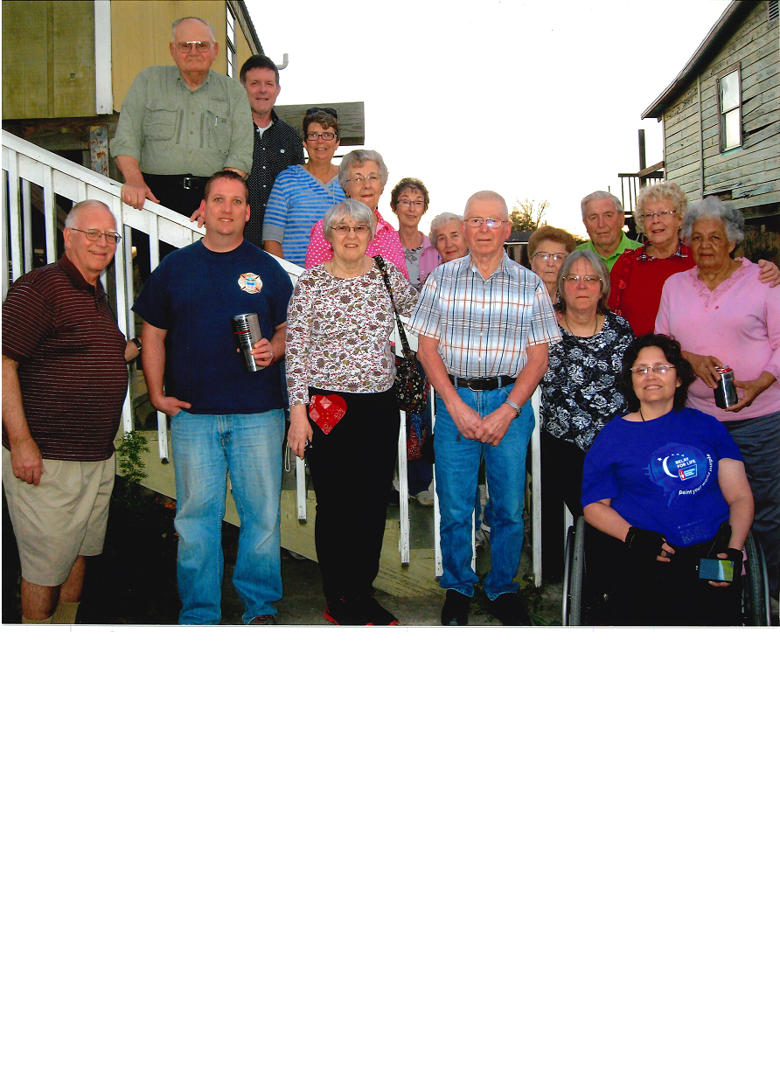

2018 MISSION TRIP

February 17-24, 2018

“Go into all the world and proclaim the Gospel to the whole creation.” Mark 16:15

Forest Hills United Methodist Church’s involvement as a mission trip began in the mid 90’s and crews have been going yearly to Dulac and Chauvin ever since. Our hearts broke when we learned of the devastation that hurricanes that destroyed much of the area. Seven major hurricanes in the last 25 years like Katrina, Rita and Ike tore these communities apart. So much of our initial work was rebuilding homes, roofs, and churches destroyed in those hurricanes. Since then, we have done construction work on individual homes, and helping to update the Community Center and church who hosted us. In 2003, the Kasson United Methodist Church joined us in the ministry. In 2015, 22 of us went to share our gifts. What gifts and talents can you share? Construction is not the only work we do! Many do sewing for curtains, drapes, and alter clothing that the Dulac residents provide. And have you ever tried to feed 22 people three meals a day for five days? It is a day long job making sure we are fed. So another team prepares, cleans up and also prepares snacks for our breaks on other work sites. Another team does electrical and plumbing work. Yet another team became “gophers” bringing building supplies, tools, and food we need during the week. We are hosted on property owned by the National Division of the United Methodist Women. The complex began in 1932 by two missionary women who had a vision of bringing education to the children of Houma, a larger town near Dulac. Since then, many buildings, mobile homes used as dormitories, and a church have been built in Dulac. During our stay, we are housed in two buildings. One is a dormitory for men and women with ten bunk beds and a common bathroom and shower facilities in each section. It has a common meeting room where lots of hot Domino and cribbage games take place in the evening. Many are so tired in the evening that we sit around and just get to know each other better. . . and sometimes go to bed earlier than we normally do! The second facility is our cafeteria in the administration building. It is also the room where all of the sewing ministries take place. Some volunteers choose to work the whole week. Others of us, though, for a break during the week, have a “field trip”. We have visited Sager Brown, the huge supply depot and dormitories operated by UMCOR (United Methodist Committee on Relief) in Baldwin, Louisiana. That’s where all of our school bags, cleaning supplies, health kits and bedding and birthing kits are stored for when catastrophes hit worldwide. In a moment’s notice, our church can deliver hundreds of supplies for those in need. It’s an incredible site to see. You will appreciate the worldwide ministry our church has through all of our churches. Along the way we see antebellum homes that are magnificent! Other times we have gone to see a Coast Guard facility on the Gulf Coast an easy drive from Dulac.

