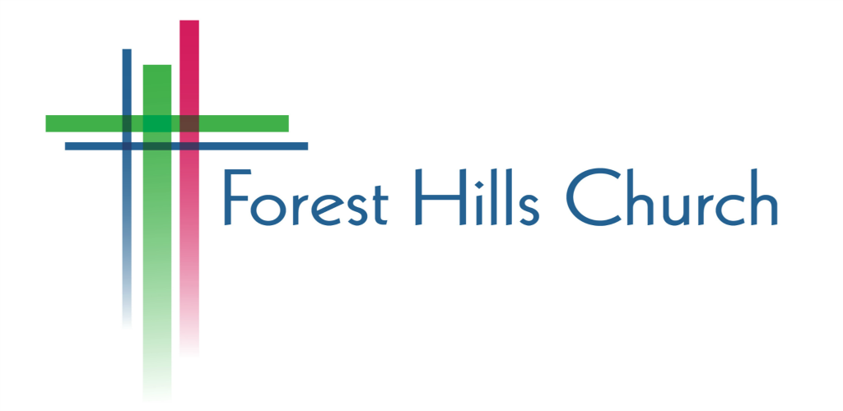

Grow Group Covenant

Welcome! We are excited to have you be a part of grow groups at Forest Hills! In the coming weeks we will meet together to grow deeper in our relationships with God and with each other. The members of each group are asked to review and commit to the covenant below. We know that a healthy group needs to be a priority for everyone involved, so together we make the following commitments:

- I will make group attendance a priority by attending each week and openly participating.

- I will pray regularly for my group partners.

- I will treat my group partners in and out of group by listening to understand, speaking in helpful ways, and keeping in group what is shared in group.

- I will come with an openness to how God wants to grow me spiritually.

- I will contribute to the ministry of Forest Hills Church through my regular attendance and support and by inviting others.

Signed,

Name: _____________________________________________________

Date: ______________________________________________________

