Forest Hills United Methodist Church
December 10, 1967 - 2017

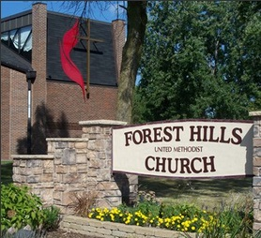
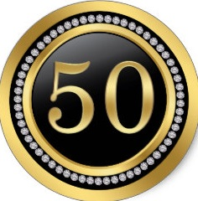
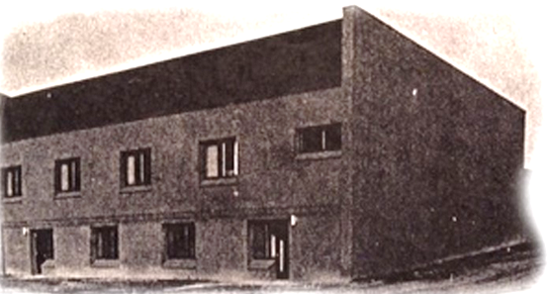
Jubilee: Remember. Renew. Rejoice.
50
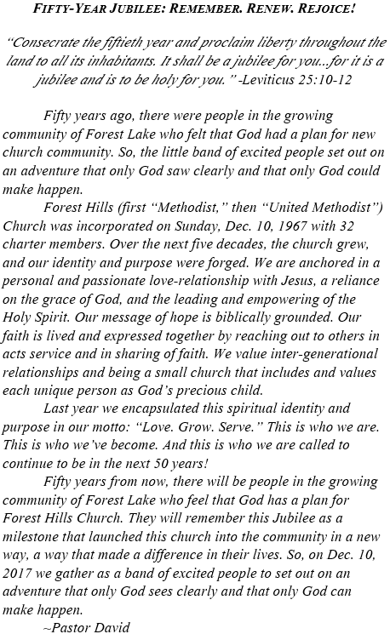
A Brief History of Forest Hills UMC
1967 - 2017: Celebrating 50 Years of Ministry!

Origins
In the early 1960s, the Methodist Episcopal (ME) Church in Wyoming had people attending from the nearby Forest Lake area. As the community was growing, discussions began about establishing a ME church in Forest Lake.
In 1964, the St. Paul Council of Churches gave Forest Lake permission to charter a ME church. Then, in early 1967, the Minnesota Annual Conference of the ME Church invited people from the Wyoming ME church and area to attend a meeting about the viability of a new church in the area. The vision was cast for a local Methodist congregation that reached out in both witness and service to its own local community. These two emphases became part of the new church’s DNA from the beginning.
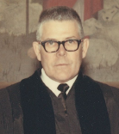
Rev. Forest V. Strnad, pastor of the Wyoming ME Church, began holding worship services in the Forest Lake Elementary School. The St. Paul District Builders of the ME Church donated a 5½ acre lot on the southeast edge of Forest Lake (near the Forest Hills Golf Course) to the new congregation.
By December of 1967, worship was moved to a mobile trailer that served as a chapel located on the new lot. Fifty-five charter members incorporated Forest Hills ME Church on Sunday, December 10, 1967. Interestingly, the congregation’s first budget (1968) was $4,025.
The mobile chapel was destroyed by fire on Maundy Thursday, April 11, 1968. St. Peter's Roman Catholic Church generously offered the use of its fellowship hall for the Easter Service. Services were then held in the local Masonic Temple as the first building was being constructed. It was also in 1968 that the ME denomination changed its name to the United Methodist Church (UMC), and so the local congregation became Forest Hills United Methodist Church (FHUMC).
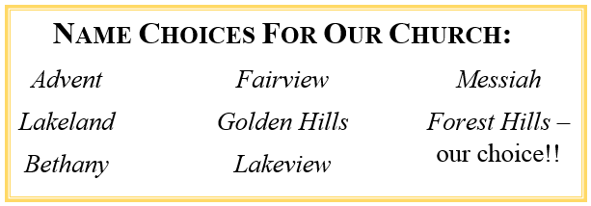
The first service in the new building was held on October 25, 1970, with consecration on November 9, 1970. The two story, brick building was set on the south end of the lot. Upstairs was the sanctuary, kitchen, and offices; the lower level was class rooms. In 1970 the congregation had 94 members and an average worship attendance of 67.
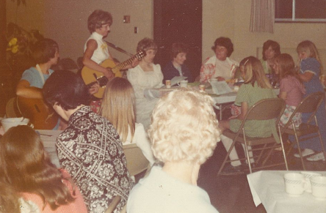
The young congregation was active from the beginning. It intentionally reached out to people of all ages with programs for children, youth, and adults. The first baptism of the new congregation was Mary Elizabeth Reese on the day of incorporation, Dec. 10, 1967. The first wedding in the new building was Shirley Branum to Thomas Borchardt on May 11, 1973. A core value of the congregation has always been inter-generational relationships and reaching families. The first father-son banquet was May 1973, and the first mother-daughter banquet was May 1976.
The women of the congregation have always helped lead the congregation in mission work. The Woman’s Society of Christian Service (WSCS) chartered on January 30, 1969. It became the United Methodist Woman (UMW) in 1972. The first fall bazaar (craft sale) was hosted in 1971. The first women’s circle, Mary Circle, started in March of 1973. The main purpose of the UMW continues to be supporting local, national and overseas missions, with special focus on helping women and children. In addition to raising awareness, prayer and financial support for missions, the UMW continues to provide resources for the church nursery.

The 1970s: Growth
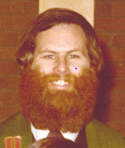
The Rev. Forest Strnad of Wyoming UMC served FHUMC as the founding pastor from 1967 until 1972. The Rev. Robert Ford followed him for the next five years. It was during Ford’s pastorate that the average weekly worship attendance grew to over 100, and the membership grew to over 160. The first parsonage was purchased in June of 1974. This building still stands in Forest Lake. A new organ was also purchased for the sanctuary in 1977.
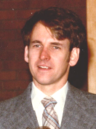
The congregation continued to grow along with the Forest Lake community. The Rev. Alan Smiley served the church from 1977 until 1983. It was under his ministry that the worship attendance grew to over 120 per week, and the membership grew to over 200.

The 1980s: Expansion
It was The Rev. Dr. Peter Law who served the church for the next ten years, marking the longest pastorate at FHUMC to date, and perhaps one of the most influential. Under Rev. Law the congregation solidified its more conservative theological grounding and grew in its emphasis on holiness and the work of the Holy Spirit. This was a time of growth for the congregation: in faith, in social witness, and in numbers. The congregation celebrated its 25th anniversary in 1992.
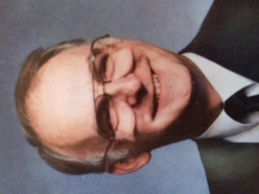
A new parsonage was built in a new development just a half mile north of the church building. Rev. Law moved in the new parsonage in 1983.
The congregation also drafted plans for an addition to the church building. A ground-level sanctuary, office space, lobby, kitchen and fellowship hall were completed in 1987. The first worship service took place in the new sanctuary on June 7, 1987. The first baptism in the new sanctuary was Kassondra Marie Humphrey, granddaughter of long-time members of the congregation, on July 27, 1986.
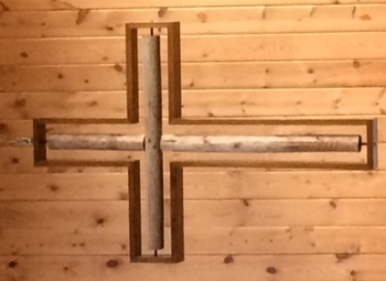
As Forest Hills expanded its building site in 1987, the desire for a cross to grace the new sanctuary emerged. David Ash and Warren Seavey were given the task. They leaned toward the “old rugged cross” concept with a new motif. They contacted Gerry Gustafson for his help. He dug around a woodpile and found some old fence posts. They created a cross from these and supported it with a modern sturdy oak cross frame that we see in front today. Darrell Benson created and built a rail system to help move the cross forward and back as needed. It met our expectations and our cross is like no other.
Shortly after the addition was finished, FHUMC began housing a Head Start program in the lower level of the original building. It continues to use that same space today!
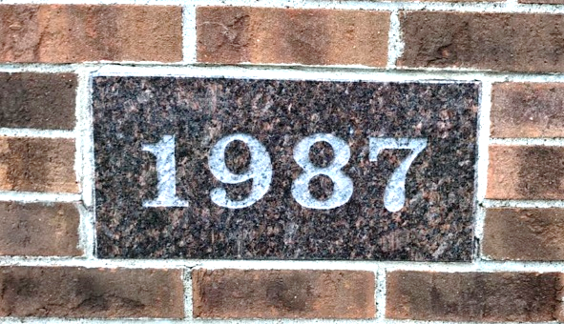

The congregation continued to experiment with creative ministries. For example, Rev. Peter Doidge from Scarborough, England, served FHUMC as an exchange pastor in its new sanctuary for the month of July, 1987. The first madrigal program, “Christmas with the Wesleys,” was hosted in December 1987. This demonstrates the congregation’s deep Methodist and Wesleyan roots. Further, the UMW slowly upgraded the kitchen to enable all kinds of meal-preparing ministries. Meal serving (with dishes and clean-up by the men!) has been a signature way that FHUMC has reached out to people not only in the congregation but also in the wider community.
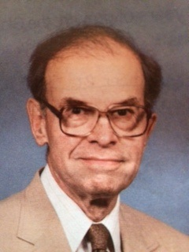
Forest Hills UMC has long offered small groups as an important way that people can grow and mature spiritually. The first Disciple Bible Study group was launched in the fall of 1987 and continued to grow and expand over the next decade. The Rev. John Blackford began a 25-year ministry of hospitality and spiritual leadership at FHUMC in retired status. Rev. Blackford helped make FHUMC a strong supporter of camping and affiliated FHUMC with Red Rock Camp Meeting.
The 1990s: Restructuring
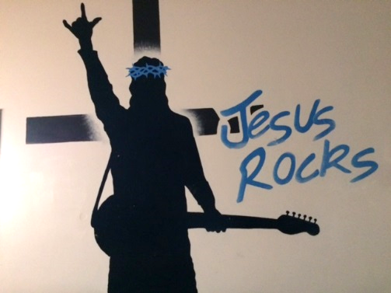
By the early 1990s, growth in the congregation (worship attendance averaged 180, membership was 330) led to several important changes. In the spring of 1992 the congregation hired its first youth worker, Justin Lefto. In September of that year, a second worship service was added. David and Hellen Ash went on a short-term mission trip to Antigua, Puerto Rico, in 1991. This prompted a desire among the congregation to seek mission work opportunities. In February,1993, the church sent its first mission team to Dulac, Louisiana, for a work week. A team has gone from FHUMC each year since; a couple of people have gone every year! Twenty-five years of Dulac Mission week service will be celebrated with the 2018 team!
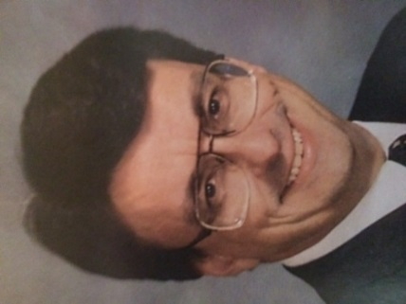
The Rev. John Mueller Nowell followed Rev. Law in 1993 and served FHUMC until the new millennium. The congregation continued to find new ways of reaching out to others with the love of Jesus. It sent the first mission team for a week of service in the Appalachia Service Project (ASP) in 1995 to West Virginia, and has continued to send at least one team nearly every year since.
In 1997 the congregation started what still is its signature local outreach ministry: Community and Car Care Saturday. One Saturday a month the church hosts a food distribution on site to 150-200 local families. The food suppliers have changed over the years; currently it is Ruby’s Pantry. The same morning, volunteer mechanics also repair cars for those in need. More recently the Car Care program has partnered with a local repair shop to take on larger and more complicated repair needs.
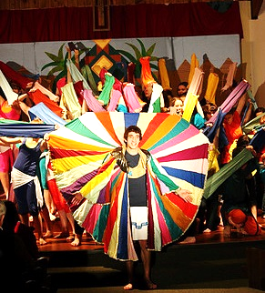
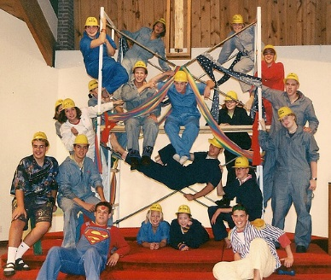
In 1999, members of the congregation started a well-known youth drama program in the Forest Lake community called Youth Performing Arts (YPA). Although YPA is an independent ministry, FHUMC houses its rehearsals and productions in the church sanctuary two to three times a year. Between 30 to 90 youth are involved at any given time, and they have put on such productions as Godspell, Les Misérables, and Joseph and the Amazing Technicolor Dreamcoat. YPA is an independent ministry, although FHUMC is well-known in the community as its church host.
Godspell 1999
Seussical 2014
Joseph 2013
Rev. Mueller Nowell led the congregation to redesign its leadership structure in 1999. It moved away from an administrative council to what is called the Ministry Leadership Team (MLT). The ministries of the church are divided in to four ministry areas: Worship, Nurture, Outreach, and Resource. The Lay Leader, the leader of each of the four ministry areas, the Staff-Parish Relations Team lead, and the pastor comprise the MLT. Each of the four ministry areas is then divided into various ministry teams as needed. MLT sets the vision of the church, cares for its ongoing operations, and controls the church’s financial budget and expenditures.

The congregation also adopted its official Mission Statement: “We are a church that seeks to reach people for Christ and make disciples by being the visible love of Jesus Christ in our communities.”
Although worship attendance and membership had started to decline slightly by the time Rev. Mueller Nowell left in 2000 (weekly attendance 175, membership 260), the congregation remained energetic in ministry and outreach. The youth ministry, for example, was thriving, and the weekly youth program had an attendance of about 20 youth!

2000s: Back to Mission
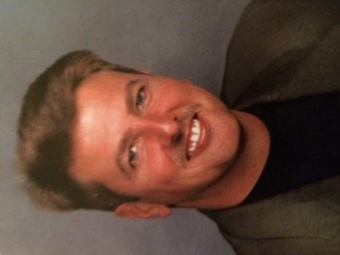
The Rev. Dr. Jack Shields served for nine years from 2000 - 2009. The congregation made a concerted effort to rekindle it’s focus on reaching new people in the local communities. It again focused on children and revamped the children’s ministry. Rather than continuing Sunday School on Sunday mornings, the congregation moved its instruction time for kids to Wednesday evening. It began hosting the now stable Wednesday evening meal and AWANA program. Before long, Kid’s Church was started during Sunday worship as a worship experience appropriate for children. Further, the congregation started the Children’s Performing Arts (CPA) program as a drama program for grade school children. In 2010, CPA became an independent, self-run ministry.
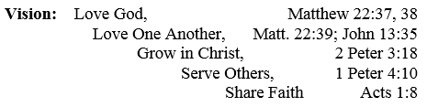
Rev. Shields led the congregation in focusing its vision, and the congregation adopted its official Vision Statement: “Love God, Love One Another, Grow in Christ, Serve Others, Share Faith.” The congregation also adopted the Rule of Christ as a way of building unity and fostering teamwork. Further, the church’s field was developed into a ball and recreation field usable to the surrounding community.
Ministry staffing continued to develop. A part-time Director of Children’s ministries was hired in 2003*. The first Worship Director (half time) was hired in 2005*. The children’s and youth staff positions were combined into a full-time Director of Nurture in 2007*.
Although initially under Rev. Shield the church saw a brief swell in attendance, the congregation continued to decline. Several reasons attributed to this, including the rise of local independent congregations, and the overall decline in church affiliation, especially true in suburban America. The weekly worship attendance in 2009 was 138 and the membership 301.

2010s: Revitalization
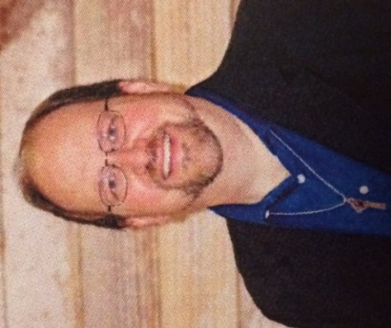
The Rev. Dr. David Werner is the current pastor, beginning his ministry at FHUMC in 2009. The congregation renewed its commitment to revitalization and its calling to reach new people for Jesus in the local communities. In 2010, the congregation drew upon its long heritage of both witness and service and adopted two Action Statements:
Action Statement 1: We are committed to loving and serving families in our community with children, youth and young adults, and expect an increase of families who make Forest Hills their church home.
Action Statement 2: In seeking to serve the whole person, we will strive to provide basic, tangible needs for those in our communities and world.
The mission, vision, and action statements helped focus the congregation to make some important changes. In 2011, the two worship services, one traditional and one contemporary, were combined into one, offering authentic components of various styles of worship. A building campaign in 2013 paved the parking lot, redid the curb and sidewalks, added lights to the parking lot, bricked the north side of the church building exterior, added entry-assisted doors, remodeled the main-level bathrooms, upgraded the lobby and sanctuary lighting, and updated the technology in the sanctuary.
In 2016, new icons, along with distinct colors and a new cross logo, were introduced to streamline the church’s message: Love. Grow. Serve. The graphics and colors were applied cohesively across all the church’s media, and the lobby was updated to incorporate the new look.
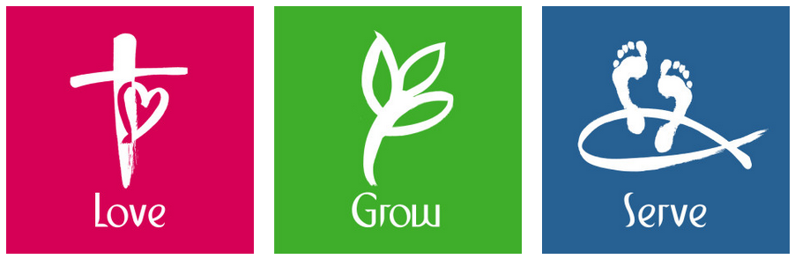
Staffing continued to develop creatively. In 2015, a part-time Director of Spiritual Growth was tried for a year. In 2016, the Director of Worship position was combined with the Director of Children’s Ministries into one, full-time position. Also in 2016, the church hired a half-time combined Director of Youth Ministries and Director of Visual Media on an experimental basis.
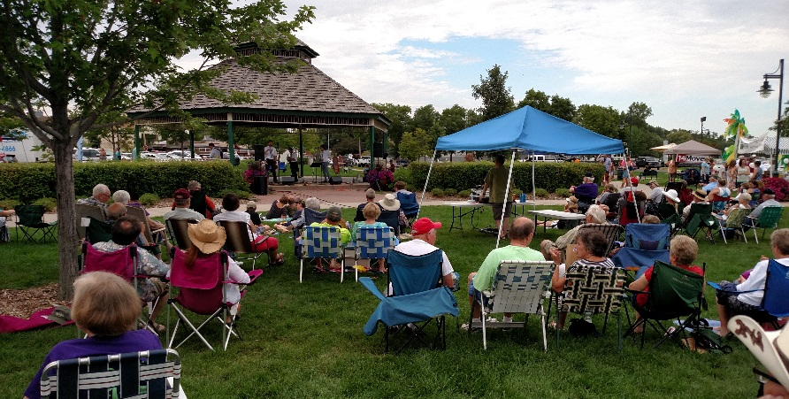
The church continues to explore innovative and creative ministry outreach. In 2010, the congregation expanded its annual festival into a community festival hosted by all area churches, raising support for local, national, and international projects. Then, in 2014, the festival was made the Annual Bluegrass Festival of Forest Lake.

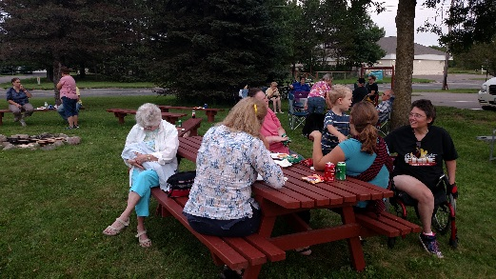
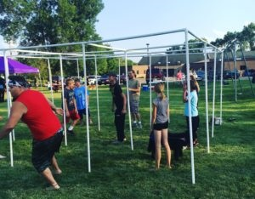
Also in 2014, the church began the annual tradition of free summer BBQs on the church lawn in August. New life-sharing small groups were added to the more traditional study, fellowship, and service groups, in 2015. In 2016, an experimental Christmas Camp was offered during the school break. It will replace VBS in the future!

The Present: 50 Years Vital!
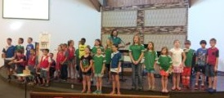
On this 50th year of ministry, FHUMC is faithfully and excitedly bearing witness and service to the communities for Jesus. One Sunday morning worship service is offered at 10 a.m., (average attendance 105) as well as several other occasional and more unique worship experiences. In the Nurture Area we offer Kids Church (8-12 kids), Awana (35 kids), VBS (30 kids), confirmation (8 students), youth group (6 youth), 12 small groups (with over 40 people in study, fellowship, service, and sharing life groups), UMW in three Circles (35 women), UMM (10 men), Prayer Shawl Knitters (6 women), Comfort Quilters (10 women), five prayer teams (22 people), and a Bible Journaling class.
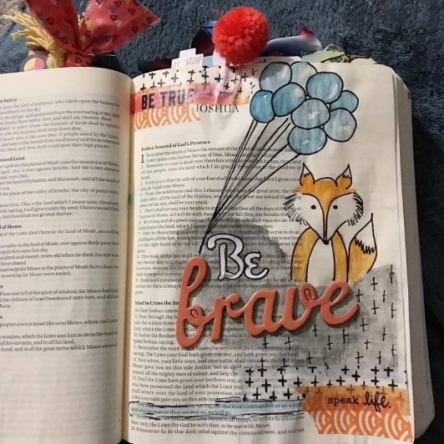
Forest Hills is a church that holds together both evangelical witness and social justice. It continues the monthly Community Care (serving 160 families) and Car Care programs (servicing 6 cars), three mission trip teams (30 people), the annual Bluegrass Festival and summer BBQs (80 people), and monthly and weekly appeals for needs locally, nationally, and around the world.
Our facilities are offered as an extension of ministry, hosting Head Start, Narcotics Anonymous, Boy Scouts, Girl Scouts, MOMS Club, YPA, AARP Tax Aid, ball teams, and more occasionally other groups, all on site.
In order to discern what God has planned for FHUMC in the years ahead, this year the congregation has begun the Healthy Church Initiative (HCI) journey. The congregation boldly voted to accept the five-fold recommendation to 1) Pause many of the ongoing administrative and ministry activities of our church for one year in order to connect more deeply with Jesus, 2) Make Sunday worship a simple, soulful experience for all ages, 3) Have Wednesday evenings be a meal and fellowship time that building relationships among all ages, 4) Host inter-generational small groups that nurture our faith, and 5) Dream a new dream, capturing God’s plan for our church in the next 50 years! There is growing excitement about how God will continue to make FHUMC into the missional church God intends for it to be!
May God continue to bless FHUMC as God continues to make FHUMC a blessing.
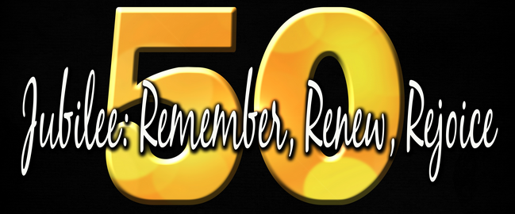
Happy Golden Anniversary, FHUMC!
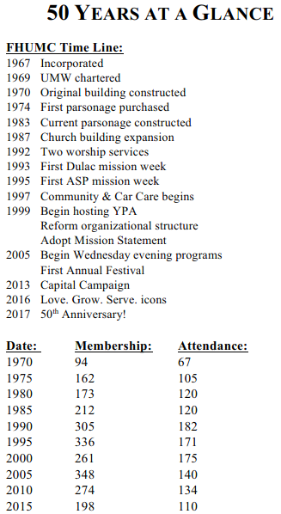
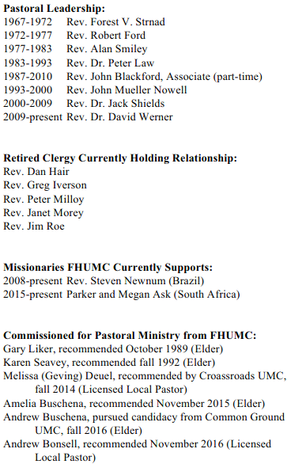
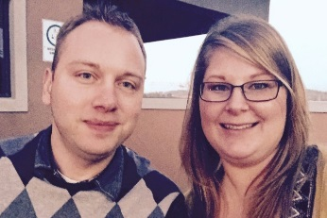
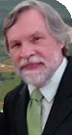
Forest Hills Firsts
First service - December 10, 1967
First Pastor – Rev. Forest V. Strnad
First Members – 52
First wedding –Shirley Branum and Thomas Borchardt
First Budget - $4,025
First Baptism - Mary Elizabeth Reese
First Bazaar – Fall 1971
WSCS Charter – January 30, 1969 (UMW in 1972)
First Circle – Mary Circle March 1973
First Father/Son Banquet – May 1973
First Parsonage – June 1974
First Mother/Daughter Banquet –May 1973
Purchase of new organ – spring 1977
First service in new sanctuary – June 7, 1987
First Madrigal Dinner “Christmas with the Wesleys” December 1987
First Baptism in new sanctuary – Kassandra Marie Humphrey
First Exchange Pastor – Rev. Peter Doidge of Scarborough England – July 1987
First Disciple Group – fall 1987
First person sponsored for the seminary – Gary Liker – October 1989
First hired youth worker – Justin Lefto – spring 1992
First effort to change to two services – September 1992
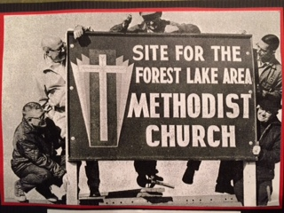
First mission trip to Dulac Louisiana – February 1993
First ASP trip to West
Virginia – 1995
First Car Care Saturday 1997

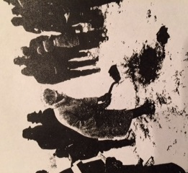
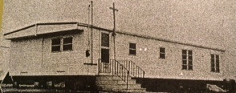
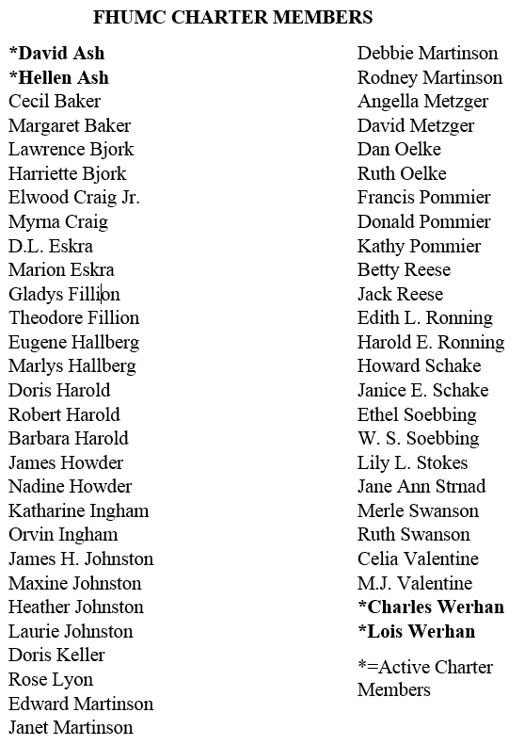
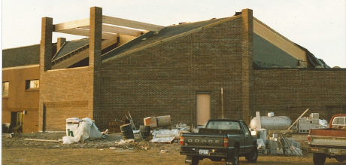
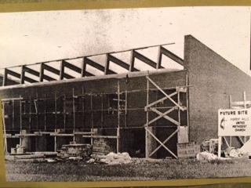
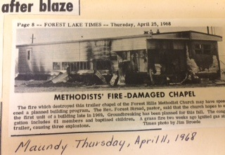

Love. Grow. Serve.

ASP
A Christian Ministry, open to all people, that inspires hope and service through volunteer home repair in central Appalachia.
The first ASP trip from Forest Hills was begun by John and Kyle Mueller Nowell in 1995. There have been approximately 17 total trips to Appalachia since. Some of the counties where work was done include Breathitt, Perry, Knott, Letcher, Knox, Laurel, Wolf and Martin Counties in Kentucky; Tazewell, Grayson, Wayne, Logan, and McDowell Counties in Virginia and Scott County in Tennessee.
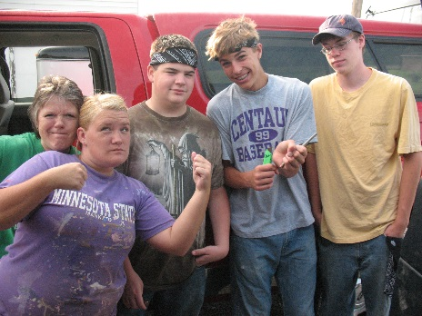
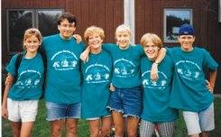
Teams caravanned in vans and trucks down to Lexington, Kentucky staying at volunteer churches along the way. They settled into local schools for the work week, communally sharing breakfast and supper chores. Evenings were filled with guest speakers, devotional group time, games and early bedtimes. Each last work day culminated in a big family picnic, gift giving, picture taking and of course very emotional goodbyes. Tearful large group sessions reflecting on the week’s experiences lasted long in to the evening. Then the long trip home often included a stop at the Lake Michigan Sand Dunes.
All who participated in ASP were forever changed.

UMW & Circles
Thirteen charter members started the WSCS back in 1969. The Women’s Society of Christian Service grew in to the United Methodist Women (UMW) as we know it today.
Three Circles evolved from that – Mary Circle with nursery services in 1973, followed by an evening Rebecca Circle in 1978 and an afternoon Sarah Circle in 1981. The most recent circle, Eat! Pray! Love! has since become WOW (Women of Wisdom).
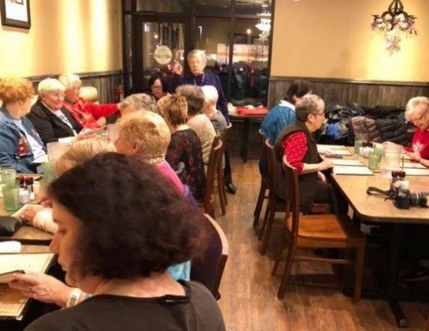
The Circles’ mission is focused on women and children; concentrating on raising money and doing projects locally, across the country and around the world. That involves making Head Start quilts, prayer shawls, mittens, raising $$$ through Craft Sales and Luncheons, rummage sales for Emma Norton, John Blackford Red Rock Camp scholarships and Head Start. Of course, some fun activities such as the May Day party, a summer outing, UMW Sunday and the traditional Christmas party e held to keep members involved and encourage others to join.

Dulac
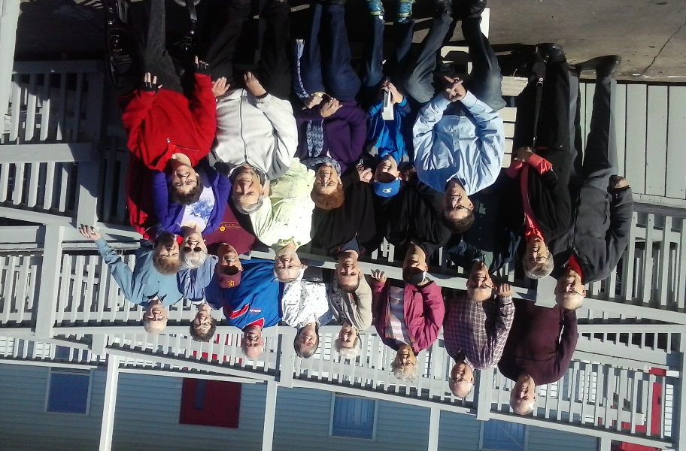
Dulac, Louisiana has been rocked and ripped apart by four hurricanes since 2005. The Dulac Community Center walks hand-in-hand with its community through social, recreational, and emergency support, repairing damage to area homes, Vacation Bible School for local children, and providing resources in the thrift store and library. Forest Hills friends and members have trekked southward since 1995 to help.
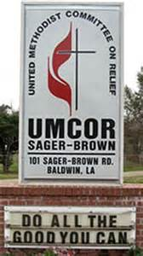
Often a side trip for the Bergersons is stopping at UMCOR (United Methodist Committee on Relief) in Baldwin, Louisiana. They deliver a variety of supplies to aid in the relief process. Kay’s personal mission has been making bags that many of us fill with school supplies. She started this project in 2003 and to date has sewn over 1,577 bags! American and global students have benefitted from her efforts.
POP (Philippines Orphanage Project)
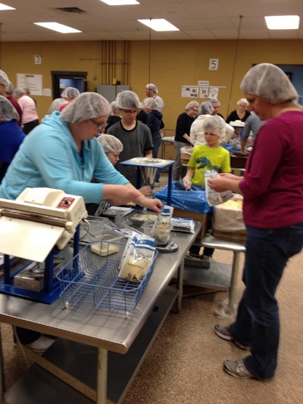
POP is a mission effort to the nation of the Philippines. Our very own Brother Jeff Krasean opened his heart to the children of the Philippines and partnered with their local United Methodist Church to create the Palawan Orphanage for these “throw away” children providing nutritional needs and sanctuary for them. Since then the orphanage has closed but food “Manna Packs” from FMSC (Feed My Starving Children) continue to feed 1000’s of children daily at nearly 40 feeding stations throughout the land. POP has expanded to include food grinders and goats. Solar powered devices spread the Gospel. As Brother Jeff said, “It’s all about the children!”

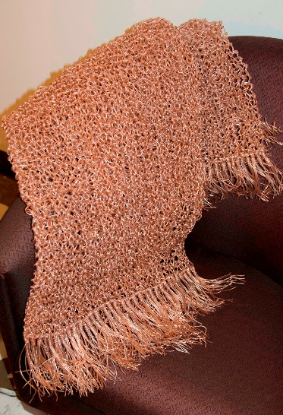
Prayer Shawl Knitters
Begun in 2004 by Debbie Carroll and Maxene Schwanke. Prayer shawls are presented to confirmands, wedding couples, new members and those facing difficulties and serious illnesses in their lives. Many women make these shawls, pray over them, and present them to the recipients. Over the years 327 shawls have been crocheted.
Comfort Quilters
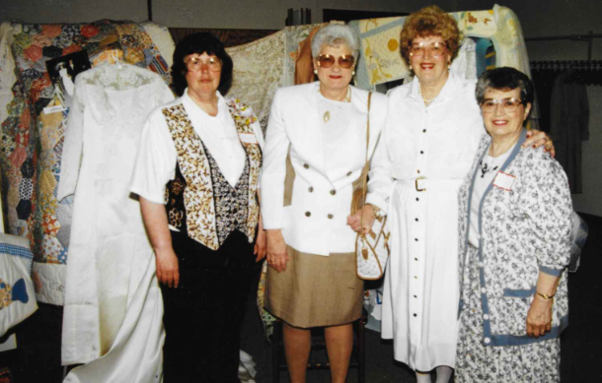
Quilting became a ministry in 1986 at JoAnne Benoy’s house where a number of members plied their talents at hand quilting. When a large donation of fabric arrived, these motivated women, including Betty Reese, Carol Sabasko, Ruth Milbrandt, Sue Dugdale, and JoAnne Benoy transferred to the church and decided to put their sewing talents to good use.
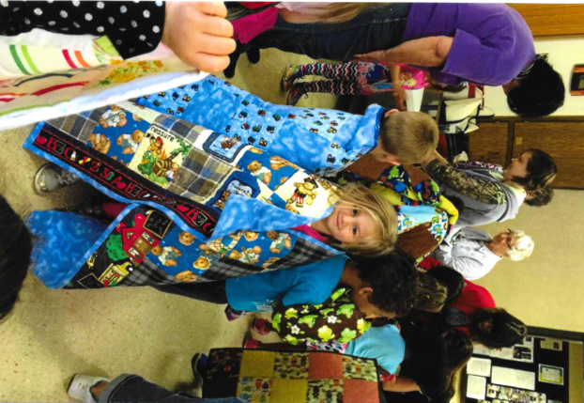
Yearly they make children’s quilts for the Head Start program housed in our church. They also stitch quilts for confirmands and graduates, Quilts of Valor for members of the military; quilts for silent auction donations, for women’s shelters such as Emma Norton, the Ronald McDonald House, babies born into our congregation and to sell at the church fall festival.
Over the years about 500 have been sewn. Comfort Quilters provides a creative outlet every Monday morning for Christian service and fellowship.

Car/Community Care
This community outreach effort was the brainchild of Walt and Maxine Schwanke back in 1996. Many volunteers from our church, other local churches and distances as far away as St. Cloud, Kimball and Cambridge, unload semi-trucks full of food and sort for dispersal every 3rd Saturday. On a typical Saturday150-200 families are served. Other volunteers offer financial advice and still others provide vehicle oil changes and small maintenance. It has become a signature outreach program for our church and truly God’s gift.
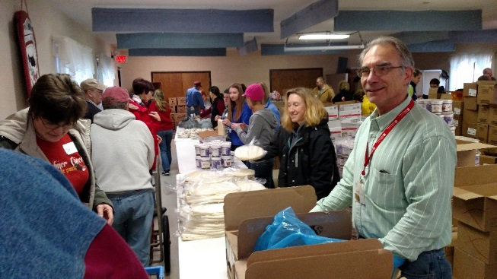
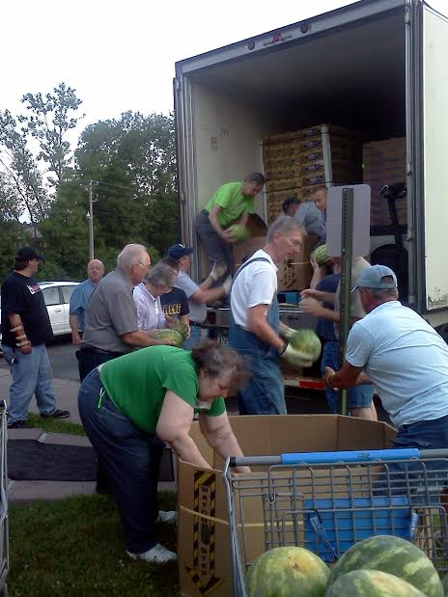
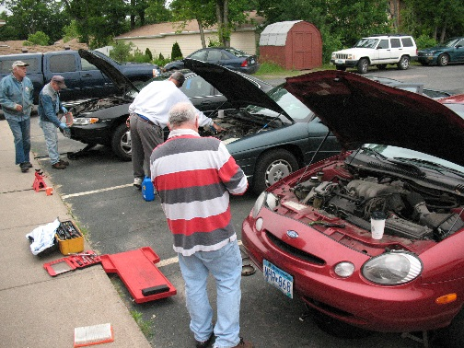
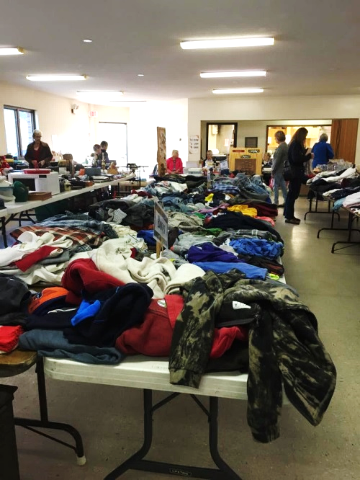
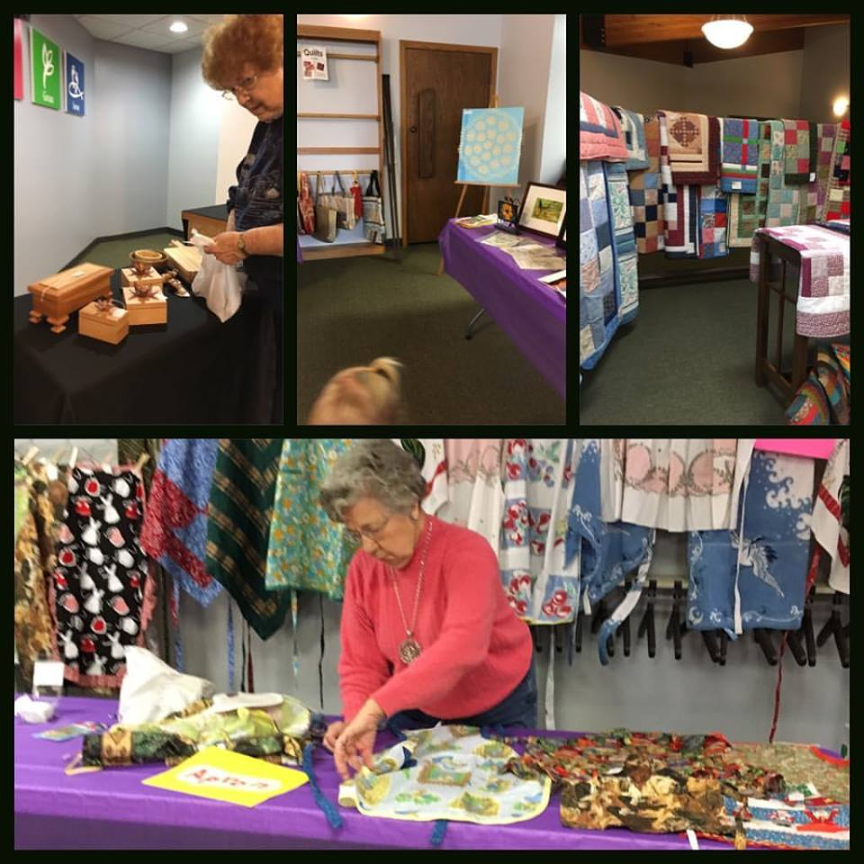
Rummage Sale and Craft Bazaar
Giving tree
The Giving Tree started in 2007, and has since become a way to raise funds for specific mission projects during the Christmas season. Each year a creative Giving Tree is decorated with representational ornaments that show the giving to the project.
Projects have included Community Helping Hands Food Shelf, Imagine No Malaria, UMCOR - global mission support, Human Trafficking, Homelessness and Refugees, and Compassion International (Chickens).
It's been important to me that these mission efforts were not just a plea for money, but a raising of our awareness.
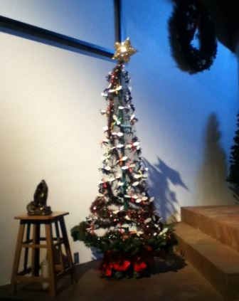
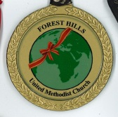
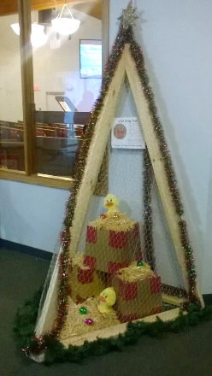
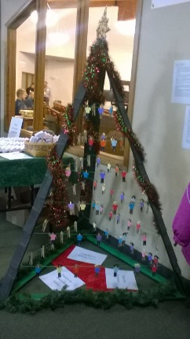
Since 2009 annual engraved Christmas ornaments have been given to those who contributed to the year's project. Sets of the ornaments are available for purchase through the office.
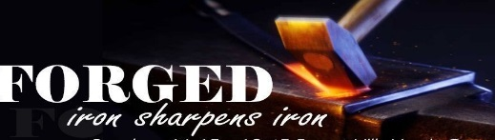
Youth Group: FORGED!
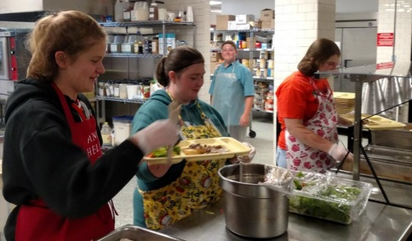
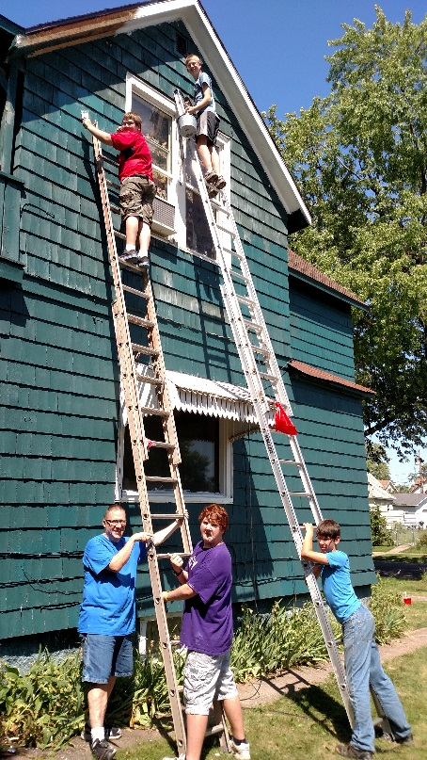
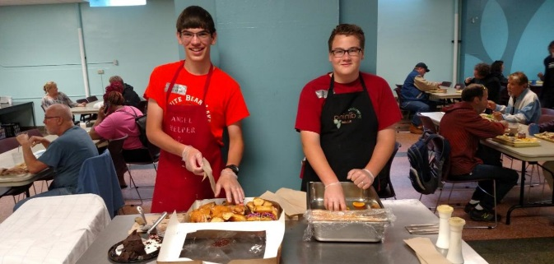
Youth ministry has been a priority of FHUMC since the beginning. Volunteers led the youth program until Christian Education was made a staff position. then, in 1992 the first designated paid youth ministry was Justin Lefto. Appalachia Service Project (ASP), with the first trip in 1995, and other mission trips such as Wildfire to Superior, WI (first trip 2013) have been a key component of youth ministry. Forest Hills believes passionately that youth ministry is a way that we pass on the Gospel to upcoming generations. The youth group currently, with 12 active youth, meets weekly under the leadership of Cassi Betker.
WILDFIRE!
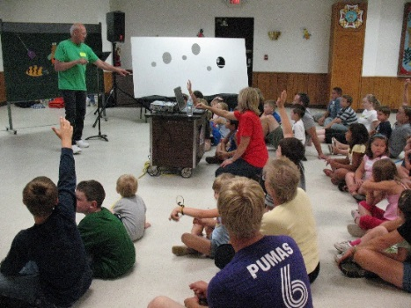
Vacation Bible School
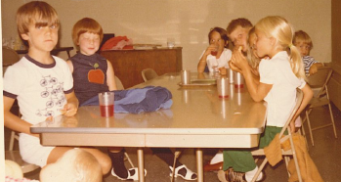
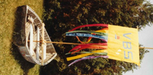
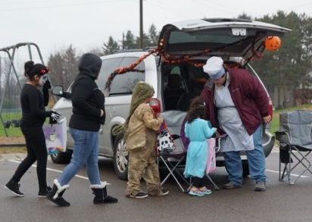
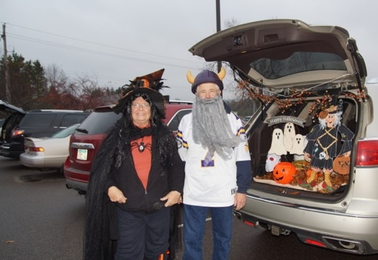
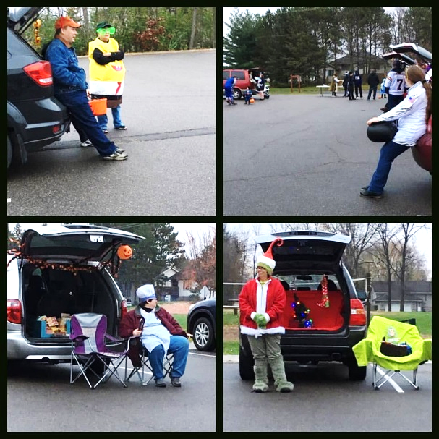
Trunk-or-Treat!
Red Rock Camp
The Rev. John C. Blackford took the first folks from Forest Hills Church to Red Rock family Bible camp in the late 1980s. Forest Hills has been sending all ages to this camp ever since! Red Rock Camp week is a time of getting away to reconnect spiritually, to make Christian friendships, and to experience God's transforming power. Forest Hills attenders have said, “It's the best week all year,” and “I first gave my heart to Jesus at Red Rock, and “I am enveloped in a Christian community that recharges me.”
In 2016, for the first time, Forest Hills earned the “most people at camp from one church” distinction, with 32 people attending! Red Rock is the last week of June at Koronis Ministries, Paynesville, MN and on June 24, 2018 the camp’s 150th Anniversary celebrations begin!
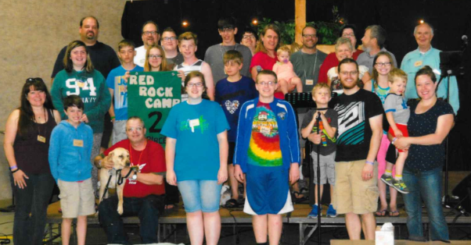
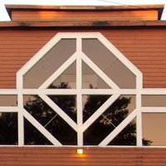
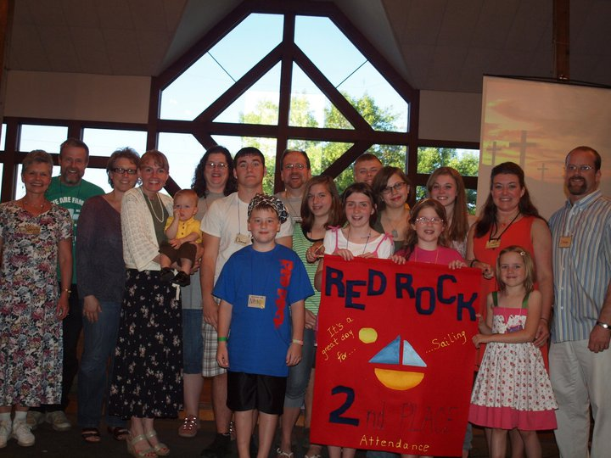

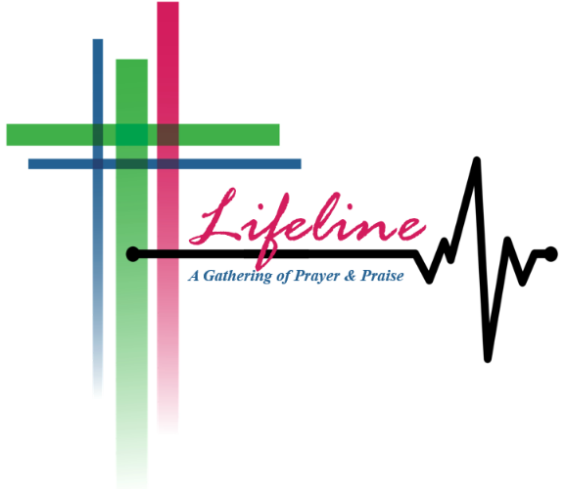
50th Anniversary Food Shelf Challenge
In celebration of FHUMC’s 50th Anniversary, the congregation committed to collect 50 each of 50 different dry goods items to donate to Community Helping Hands emergency food shelf. We wanted to let our community know of our celebration by doing what we always do: being the visible light of Jesus in our communities in ways that only God can make happen.
Not only did we get at least 50 of 50 different items, we exceeded our goal by collecting over 2,700 items! A week before the anniversary celebration, the food was delivered to a very excited Community Helping Hands food shelf! A reporter from the Forest Lake Times was on sight to capture the story, which appeared on the front page of the Forest Lake Times just days before the 50th Anniversary celebration on December 10.
God continues to do radical and amazing things through Forest Hills Church!

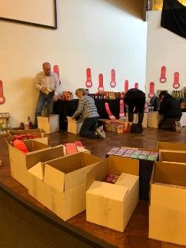
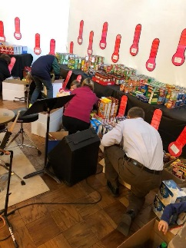
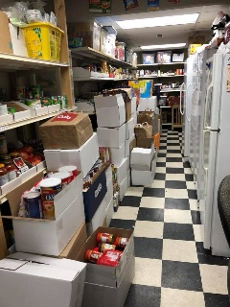
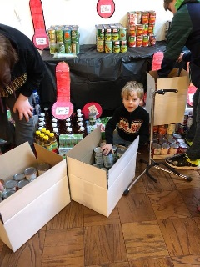

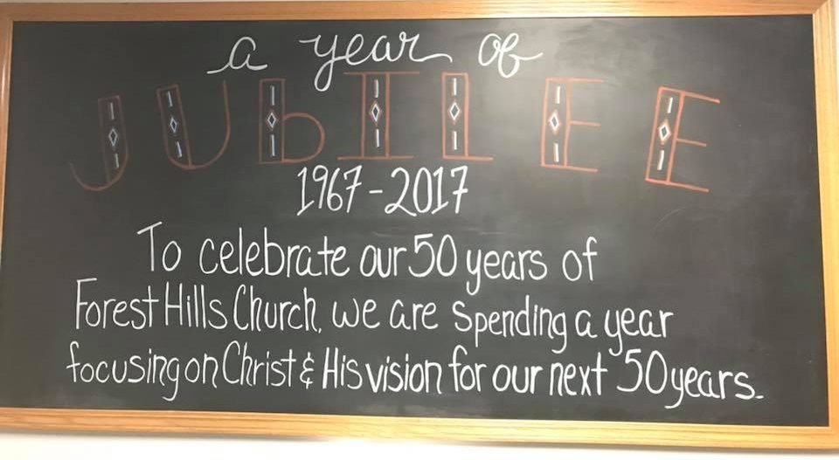
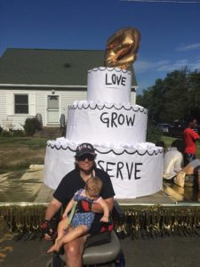
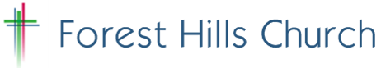

Mission: We are a church that seeks to reach people for Christ and make disciples by being the visible love of Jesus Christ in our communities.

Action Statement 1:
We are committed to loving and serving families in our community with children, youth and young adults, and expect an increase of families who make Forest Hills their church home.

Action Statement 2:
In seeking to serve the whole person, we will strive to provide basic, tangible needs for those in our communities and world.

Church Motto: Love. Grow. Serve.
“Love the Lord your God with all your heart, with all your soul, with all your mind, and with all your strength. Love your neighbor as yourself.” Mark 12:30-31

Transforming into the church God is calling
Forest Hills to be for the 21st century!
