Prayer Walk Guide
Sunday, May 17
Prayer as Worship:
Today we take a pause in our spring worship series for intentional and focused prayer. Our world and community is experiencing an unprecedented time as we live this pandemic. People are dying. Many are suffering. For all, plans and routines have changed. In addition, the many other struggles challenges of life continue, and are, perhaps, even exacerbated. Our church continues to Love.Grow.Serve. in bold faithfulness and creativity. We continue God’s mission and calling for our communities in familiar and in new ways. We continue to grow in discipleship and in making new disciples!
At challenging seasons and in times of change, God’s people have always gone to God in prayer. Our Lord showed us this also by His example (Matt. 26:36, Mark 1:35, 6:46, Luke 6:12, 9:18, etc.). So, today, we are making our morning worship a prayer walk.

Purpose:
1. Be together safely as a church community
2. Pray for our communities during this trying time
3. Grow in our discipleship through prayer, and
4. Be visible in our community witnessing to our hope in God

Memory Verse: "Pray at all times and on every occasion in the power of the Holy Spirit. Stay alert and be persistent in praying for all believers." - Ephesians 6:18

Offering: A box will be available at the back of the sanctuary for offerings.

Worship Instructions:
1. There are ten prayer stations all located through sanctuary, lobby, and fellowship hall.
2. Each worshiper is asked to observe safety protocols:
-Remaining 6 feet apart from others outside your family
-Avoiding touching anything that is not sanitized
- Waiting until the next station is open before moving there
-Wearing masks or coverings if the individual chooses to
3. Each worshiper starts at the Welcome Station. Here each person gets:
-A Worship Guide
-A pen and marker
-Six cling notes
-Popsicle stick
-Children get a bag with crayons, tree paper, and shaker for worship
-Pastor David is available to answer any questions
4. It is intended for this worship experience to last about 50 minutes, averaging 5
minutes per station.
5. At each prayer station:
-Go to that prayer station
-Turn to that prayer station’s page in this Worship Guide
-Follow the instructions in this guide
-Commit to participate as fully as you are able
-Take any items from each prayer station with you when you move on
6. When you have completed all prayer stations, you are free to leave.
7. There are bathrooms and places to sit in the church lobby if you need to use them.
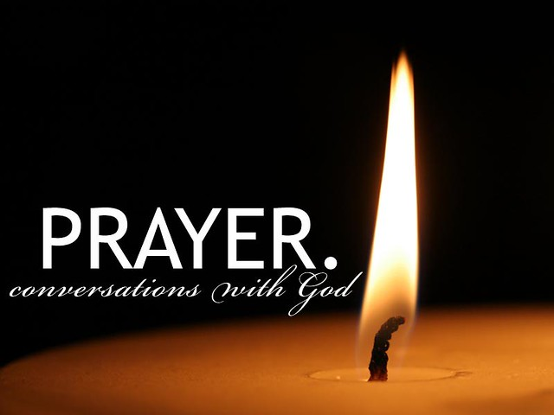

Pray in Song: Worship Prayers
Prayers: Pastor Andrew is leading worship songs with times to offer prayers. Our prayer life needs to be based on our love for God and expressing that love to Him. This is called “adoration”. Here, at the Lifeline station, we express that love to God through music and song. We encourage you to sit for a few minutes, sing along loudly or contemplate the lyrics in your heart. Kids use your shaker to add to the music being offered. Express to God your love for him.
Instructions:
- Sit/stand in the worship space and join in singing and praying.
- Words for singing are provided below.
- There will be times when participants are invited to pray out loud, either extemporaneously or using the prayers printed below. Everyone is also asked to pray silently.
- Kids are invited to make "shakers" and use them during the songs.
- Stay for as long as you like, but you are asked to stay at least through one complete song.
- When you are ready to leave, kids are invited to keep their shakers!

- Psalm 99:5 “Magnify the LORD our God! Bow low at his footstool! He is holy!”
- Psalm 98:1 “Sing to the LORD a new song because he has done wonderful things! His own strong hand and his own holy arm have won the victory!””
- Psalm 29:2 “Give to the LORD the glory due his name! Bow down to the LORD in holy splendor!”
- James 4:8 “Come near to God and he will come near to you.”

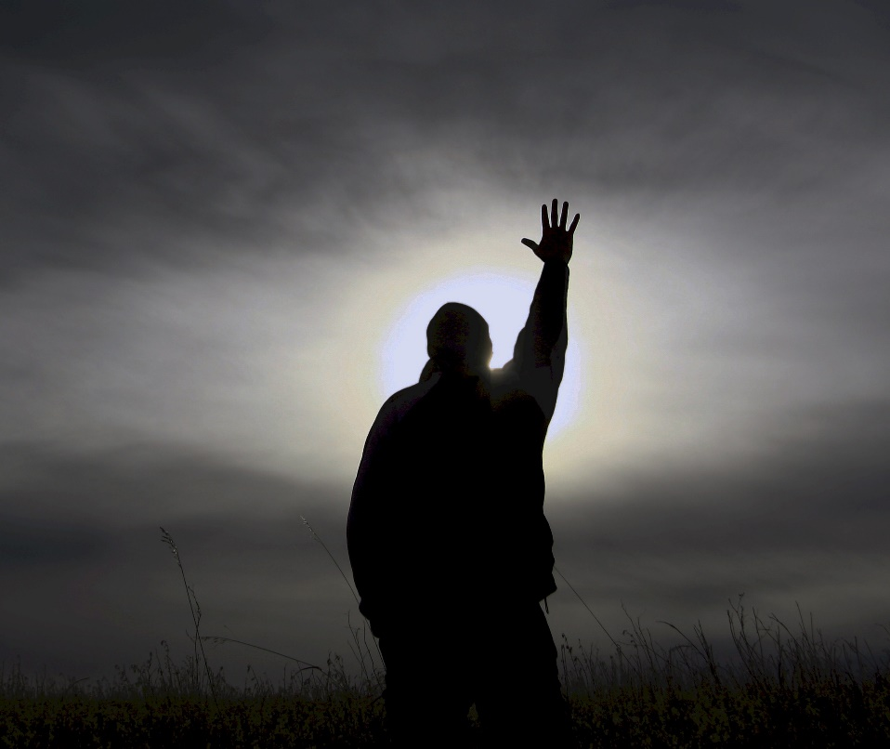

Sands of Forgiveness:
Prayers for Personal Forgiveness and Inner Healing.
Prayers: Worshipers are invited to reflect on their lives, identify personal sins, write out these sins in the sand, clear them away, and leave a greeting for the next participant.
Instructions: Choose a spot on the sand (if there is a place with a design in the sand, choose that spot first). Read: Choose to read at least one of the following Bible verses:
- Matt 6:14-15 "Your heavenly Father will forgive you if you forgive those who sin against you; but if you refuse to forgive them, He will not forgive you."
- Eph 4:32 "Instead, be kind to each other, tenderhearted, forgiving one another, just as God has forgiven you because you belong to Christ."
- 1 John 1:9 "But if we confess our sins to Him, He can be depended on to forgive us and to cleanse us from every wrong. And it is perfectly proper for God to do this for us because Christ died to wash away our sins."
- Matt 18: 21-22 "Then Peter came to Jesus and asked, ‘Lord, how many times shall I forgive my brother when he sins against me? Up to seven times?’ Jesus answered, ‘I tell you, not seven times, but seventy-seven times.’"
- Matt 5: 23-24 "So if you are standing before the altar in the Temple, offering a sacrifice to God, and suddenly remember that a friend has something against you, leave your sacrifice there beside the altar and go and apologize and be reconciled to him, and then come and offer your sacrifice to God."

Reflect: As we look into our hearts, there are times when we need to be forgiven and God forgives us. There are times when we need to forgive. God gives us the strength to forgive. How will we respond? By a prayer of thanksgiving? By promising never to do it again? By praying for the person, we have forgiven? Reflect on this. Is there something you wish to bring to God to ask forgiveness? Write or draw in the sand (use a stick, your finger, your foot) what the Holy Spirit brings to mind.
Ask forgiveness.
- Then pass your hand (or foot) through the sand, obliterating the words or images as a symbol of receiving God's forgiveness.
- Is there something (someone?) which you should forgive? Write or draw it in the sand.
- Ask God for the strength to forgive. Smooth the sand again. Now, what will your response be to God's forgiveness working through you?
- Write or draw your response in the sand and leave it for the next visitor to see. Prayer, praise, Grace, Joy, patience, etc.
- When you are ready, feel free to go to another prayer station.

Prayers of Inner Reflection –
Discerning Your Next Step in Discipleship
Prayers: Worshipers use the mirrors to pray prayers of inner reflection and to discern what the Holy Spirit may be prompting as next steps in discipleship.
Instructions: Stand over the mirrors and look down into them.
Notice: What do you see?
Move your position until you see yourself reflected in the mirrors and meditate on what you see.
Meditate: What do you think God sees?

Read at least one of the following Scriptures:
- 1 Corinthians 13:12 "In the same way, we can see and understand only a little about God now, as if we were peering at His reflection in a poor mirror; but someday we are going to see Him in His completeness, face-to-face. Now all that I know is hazy and blurred, but then I will see everything clearly, just as clearly as God sees into my heart right now."
- James 1:23-25 "For if a person just listens and doesn't obey, he is like a man looking at his face in a mirror; as soon as he walks away, he can't see himself anymore or remember what he looks like. But if anyone keeps looking steadily into God's law for free men, he will not only remember it but he will do what it says, and God will greatly bless him in everything he does."
- Jeremiah 29:11 "For I know the plans I have for you, says the Lord. They are plans for good and not for evil, to give you a future and a hope."
- 2 Corinthians 3:18 "All of us are looking with unveiled faces at the glory of the Lord as if we were looking in a mirror. We are being transformed into that same image from one degree of glory to the next degree of glory. This comes from the Lord, who is the Spirit."
- Romans 12: 2-3 "Don't copy the behavior and customs of this world but be a new and different person with a fresh newness in all you do and think. Then you will learn from your own experience how His ways will really satisfy you. 3 As God's messenger I give each of you God's warning: Be honest in your estimate of yourselves, measuring your value by how much faith God has given you."
- Proverbs 27:19 "A mirror reflects a man's face, but what he is really like is shown by the kind of friends he chooses."
Offer a prayer of thanks for who you are or take time to pray for a need you see in your own reflection.

When you are ready, feel free to go to another prayer station.

Family Tree: Praying for Our Families
Prayer: Use the handout to identify your family members by name and pray for each one.
Instructions: On the tree sketch, place yourself and your other family members. Pray for them. God has placed us in families. Some families are supportive and nurturing. Some are broken and dysfunctional. Most are somewhere in-between. Take a look at the tree on your paper. Notice how intricately the twigs and the leaves intersect and crisscross. These parts of the tree seem random and chaotic. Now observe where the branches connect to the trunk. Here the tree is stable and strong.
Families are like a tree. What seems to be messy and disordered is held together by one life giving trunk. Think about your own family. How close are you to the trunk? Who in your family seems distant from the trunk? Who is separated from the stability of God? Write these names where you feel they land on your tree, either near the trunk or further in the branches. Thank God for their role in your life. Ask for God’s presence and power to be with them.

“Be tolerant with each other and if someone has a complaint against anyone, forgive each other. As the Lord forgave you so also forgive each other.” Colossians 3:13
When you are ready, feel free to go to another prayer station.

Pocket Rocks: Praying for Others
Prayers: Take a rock and pray for someone you know in need. Put it in your pocket.
Instructions:
Pick a rock from the pile.
Feel the shape of the rock, notice the different colors and features of the rock.
Now think of someone you know who is in need.
Consider the rock as a reminder of that person. Pray for them and their need.
Read at least one of the following Scriptures for inspiration:
- Ephesians 6:18 "Pray all the time. Ask God for anything in line with the Holy Spirit's wishes. Plead with him, reminding him of your needs, and keep praying earnestly for all Christians everywhere."
- Colossians 1:9 "Because of this, since the day we heard about you, we haven’t stopped praying for you and asking for you to be filled with the knowledge of God’s will, with all wisdom and spiritual understanding."
- James 5:16 "Admit your faults to one another and pray for each other so that you may be healed. The earnest prayer of a righteous person has great power and wonderful results."
Put the rock in your pocket (or bag). Carry the rock with you all week and pray for them each time you notice that rock in your pocket. Prayers go a long way and God will hear you.
After you carry it for a week, put the rock in your garden. Then continue to pray for that person and their need every time you walk by.
When you are ready, feel free to go to another prayer station.

Prayer Wall: Prayers for the Needs of Our Communities
Prayer: Place three cling notes on posted sheets about our community.
Instructions:
Go to the prayer wall and look over the community sheets posted.
Reflect on your neighborhood.
Choose three areas for which you want to pray.
Take three cling notes and place them near the posted sheets for which you prayed.
Pray for your needs that the Holy Spirit brings to mind as you continue to pray for your local community.
When you are ready, feel free to go to another prayer station.

Prayer Wall: Praying for Our World
Prayer: Place three cling notes on posted sheets about our community.
Instructions:
Go to the prayer wall and look over the map and global sheets posted.
Reflect on the needs of our world.
Choose three areas for which you want to pray.
Take three cling notes and place them near the posted sheets for which you prayed.
Pray for your needs that the Holy Spirit brings to mind as you continue to pray for your local community.
When you are ready, feel free to go to another prayer station.
Lifting the Lost to Jesus

Praying for Those Who Do Not Yet Know Jesus
Prayer: Take a strip of cloth and pray for someone who does not yet know the saving love of Jesus as you tie/string your ribbon onto the mesh of the cross.
Instructions:
Take a strip of cloth and hold it in your hand.
Identify someone in your family or close to your heart (or some whom the Holy Spirit calls to mind) who does not know the saving love of Jesus.
Pray for that person to come to know Jesus. Ask God to place someone in that person’s life as a witness to Jesus. Also ask the Holy Spirit to call to mind any way you can show your witness for Jesus to that person.
Tie/string your cloth onto the mesh of the cross as a reminder of how you are placing them close to Jesus and His work of salvation on the cross.
Repeat this prayer as many times as you feel led for other people.
Prayer: Heavenly Father, I pray that you will give my loved one ( say their name ) faith to believe in you, soften their heart Lord and give them a heart to know you. Give them revelation in the knowledge of you. I pray you will speak to them in any way you choose to reach them. Open their eyes to see you and to hear you Lord Jesus. Lead and guide them to your truth, Jesus is the truth. Thank you, Heavenly Father, for all that you are doing in their lives so they may receive your free gift of salvation. I trust you in hearing my prayer, In Jesus name, Amen
- 1 Timothy 2:4 Who wants all people to be saved and come to a knowledge of the truth.
- Romans 5:8 But God Demonstrates his own love for us in this, while we were yet sinners, Christ died for us.
- Acts 4:12 Salvation is found in no one else, for there is no other name under heaven given to mankind by which we must be saved.
- John 3:16 For God so loved the world that he gave his one and only son, that whoever believes in him shall not perish but have eternal life.
When you are ready, feel free to go to another prayer station.

Bible Prayers: Praying the Prayers of Scripture
Prayers: Praying prayers that are given in Scripture for God’s people to pray.
Instructions: Pray at least two of the following prayers in the Bible:
- The Lord’s Prayer: Matthew 6:9-13 "Our Father in heaven, hallowed be Your name. Your kingdom come, Your will be done, on earth as it is in heaven. Give us this day our daily bread, and forgive us our sins, as we also have forgiven those who have sinned against us. Save us from the time of trial, and deliver us from evil. For thine is the kingdom, and the power, and the glory, for ever and ever."
- Aaron, Blessing for God’s People: Numbers 6:24-26 "May the Lord bless you and protect you. May the Lord smile on you and be gracious to you. May the Lord show you His favor and give you His peace."
- David, for Repentance: Psalm 51:7, 10-12 "Purify me from my sins, and I will be clean wash me, and I will be whiter than snow... Create in me a clean heart, O God, Renew a loyal spirit within me. Do not banish me from Your presence, and don’t take Your Holy Spirit from me. Restore to me the joy of Your salvation, and make me willing to obey You."
- Daniel’s Confession for the People: Daniel 9:4-19 (various) "Please, my Lord—you are the great and awesome God, the one who keeps the covenant, and truly faithful to all who love him and keep his commands: We have sinned and done wrong. We have brought guilt on ourselves and rebelled, ignoring your commands and your laws. ... Righteousness belongs to you, my Lord! ... Compassion and deep forgiveness belong to my Lord, our God ... But now, my Lord, our God–you who brought your people out of Egypt with a strong hand, making a name for yourself even to this day–my Lord, please! In line with your many righteous acts, please turn your raging anger from [us]. ... Our God, listen to your servant’s prayer and pleas for help. Shine your face on your ruined sanctuary, for your own sake, my Lord. Open your ears, my God, and listen! Open your eyes and look ... at the city called by your name! We pray our prayers for help to you, not because of any righteous acts of ours but because of your great compassion. My Lord, listen! My Lord, forgive! My Lord, pay attention and act! Don’t delay! My God, do all this for your own sake, because your city and your people are called by your name."
- Mary Glorifies God: Luke 1:46-55 "With all my heart I glorify the Lord! In the depths of who I am I rejoice in God my savior. He has looked with favor on the low status of His servant. Look! From now on, everyone will consider me highly favored because the Mighty One has done great things for me. Holy is His name. He shows mercy to everyone, from one generation to the next, who honors Him as God. He has shown strength with His arm. He has scattered those with arrogant thoughts and proud inclinations. He has pulled the powerful down from their thrones and lifted up the lowly. He has filled the hungry with good things and sent the rich away empty-handed. He has come to the aid of His servant Israel, remembering His mercy, just as He promised to our ancestors, to Abraham and to Abraham’s descendants forever."
- Zechariah Blesses God: Luke 1:68-75 "Bless the Lord God of Israel because He has come to help and has delivered His people. He has raised up a mighty savior for us in His servant David’s house, just as He said through the mouths of His holy prophets long ago. He has brought salvation from our enemies and from the power of all those who hate us. He has shown the mercy promised to our ancestors, and remembered His holy covenant, the solemn pledge He made to our ancestor Abraham. He has granted that we would be rescued from the power of our enemies so that we could serve Him without fear, in holiness and righteousness in God’s eyes, for as long as we live."
- Jesus’ Prayer of Submission: Luke 22:39-46 Jesus left and made his way to the Mount of Olives, as was his custom, and the disciples followed Him. When He arrived, He said to them, "Pray that you won’t give in to temptation." He withdrew from them about a stone’s throw, knelt down, and prayed. He said, "Father, if it’s your will, take this cup of suffering away from me. However, not my will but your will must be done." Then a heavenly angel appeared to him and strengthened him. He was in anguish and prayed even more earnestly. His sweat became like drops of blood falling on the ground. When he got up from praying, he went to the disciples. He found them asleep, overcome by grief. He said to them, "Why are you sleeping? Get up and pray so that you won’t give in to temptation."
- Jesus’ Prayer for His followers: John 17:1,9-21 "When Jesus finished saying these things, he looked up to heaven and said, ‘Father, the time has come. Glorify your Son, so that the Son can glorify you. ... I’m praying for those you gave me, because they are yours. ... I’m no longer in the world, but they are in the world, even as I’m coming to you. Holy Father, watch over them in your name, the name you gave me, that they will be one just as we are one. When I was with them, I watched over them in your name, the name you gave to me, and I kept them safe. None of them were lost, except the one who was destined for destruction, so that scripture would be fulfilled. Now I’m coming to you and I say these things while I’m in the world so that they can share completely in my joy. I gave your word to them and the world hated them, because they don’t belong to this world, just as I don’t belong to this world. I’m not asking that you take them out of this world but that you keep them safe from the evil one. They don’t belong to this world, just as I don’t belong to this world. Make them holy in the truth; your word is truth. As you sent me into the world, so I have sent them into the world. I made myself holy on their behalf so that they also would be made holy in the truth. I’m not praying only for them but also for those who believe in me because of their word. I pray they will be one, Father, just as you are in me and I am in you. I pray that they also will be in us, so that the world will believe that you sent me. I’ve given them the glory that you gave me so that they can be one just as we are one. I’m in them and you are in me so that they will be made perfectly one. Then the world will know that you sent me and that you have loved them just as you loved me."
- Paul, for the Christians at Ephesus: Ephesians 3:14-20 "For this reason I bow my knees before the Father, [asking] that according to the riches of His glory He may grant you to be strengthened with power through His Spirit in your inner being, so that Christ may dwell in your hearts through faith–that you, being rooted and grounded in love, may have strength to comprehend with all the saints what is the breadth and length and height and depth, and to know the love of Christ that surpasses knowledge, that you may be filled with all the fullness of God. Now to Him who is able to do immeasurably more than all we ask or imagine, according to His power that is at work within us, to Him be glory in the church and in Christ Jesus throughout all generations, for ever and ever! Amen."
- Paul, for the Christians at Philippi: Philippians 1:9-11 And I pray this, that your love may abound even more and more in knowledge and every kind of insight so that you can decide what is best, and thus be sincere and blameless for the day of Christ, filled with the fruit of righteousness that comes through Jesus Christ to the glory and praise of God.

Prayer Concerns: Bergie Bergerson making progress on the slow recovery. Judy Dittberner finished treatment for blood staff infection. Marilee Leonard celebrates a drop in her blood inogen number cancer treatments are working! Pray for the emotions of children who are struggling to understand the distancing from their loved ones.
Upcoming Events:
May 24 and 31 - Drive in worship
June 7 and 14 - Outdoor worship under a tent.
Movie Night delayed until June.

Take This Prayer Walk Home!
We are asking each person to extend this prayer walk into your own neighborhood! Sometime this week, take a walk (or drive) around your own neighborhood, and make it a Prayer Walk! Go back through this handout and pull out ideas for how you can pray for your own neighborhood. Below are some examples of how you can pray as you walk, even if you do not know the people you are praying for.
- Praying over every house, ever neighbor.
- If you see signs of children in the house, pray for those children to grow up knowing God.
- Pray for the parents to have wisdom and patience in their job of parenting.
- If you see signs of teenagers, pray for safety as those kids begin to stretch their wings. Pray they will find a sure path and stay well-grounded as they grow and leave the house.
- If you see a ‘for sale’ sign in the yard, pray for a smooth transition and move for the family and the new neighbors who will move in.
- If you see a bench in the front yard, pray for those who will sit upon it.
- If you see bicycles, pray for the safety of their riders.
- Pray that the members of the household may know Christ and may come to know trust and rely on his guidance for their lives.
- Pray for health and safety.
- Pray for the raising of children and grandchildren.
- If you pass by someone while walking, lift them up in prayer specifically.
- Choose a scripture and pray it as you walk. Here are some possibilities:
  - Mark 16:15 “And Jesus said to them, ‘Go into all the world and proclaim the gospel to the whole creation.”
  - Jeremiah 29:7 “But seek the welfare [wholeness, prosperity, peace] of the city where I have sent you into exile, and pray to the LORD on its behalf, for in its welfare you will find your welfare.”
  - Colossians 4:3-4 “At the same time, pray also for us, that God may open to us a door for the word, to declare the mystery of Christ, on account of which I am in prison - that I may make it clear, which is how I ought to speak.”
  - 1 Timothy 2:1-4 “First of all, then, I urge that supplications, prayers, intercessions, and thanksgivings be made for all people, for kings and all who are in high positions, that we may lead a peaceful and quiet life, godly and dignified in every way. This is good, and it is pleasing in the sight of God our Savior, who desires all people to be saved and to come to the knowledge of the truth.”
  - Luke 1:17 “…and he will go before Him in the spirit and power of Elijah, to turn the hearts of the fathers to the children, and the disobedient to the wisdom of the just, to make ready for the Lord a people prepared.”
  - 2 Chronicles 7:14 “…if my people who are called by my name humble themselves, and pray and seek my face and turn from their wicked ways, then I will hear from heaven and will forgive their sin and heal their land.”

